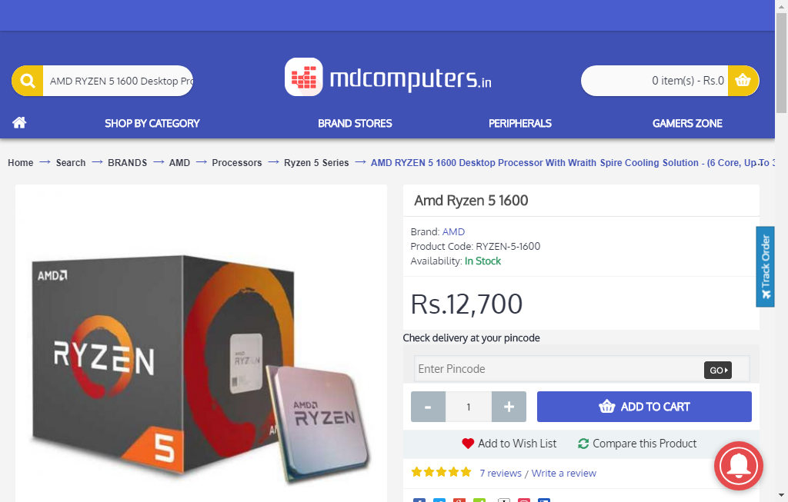  
mdcomputer_processor_29_09_2018_02_58

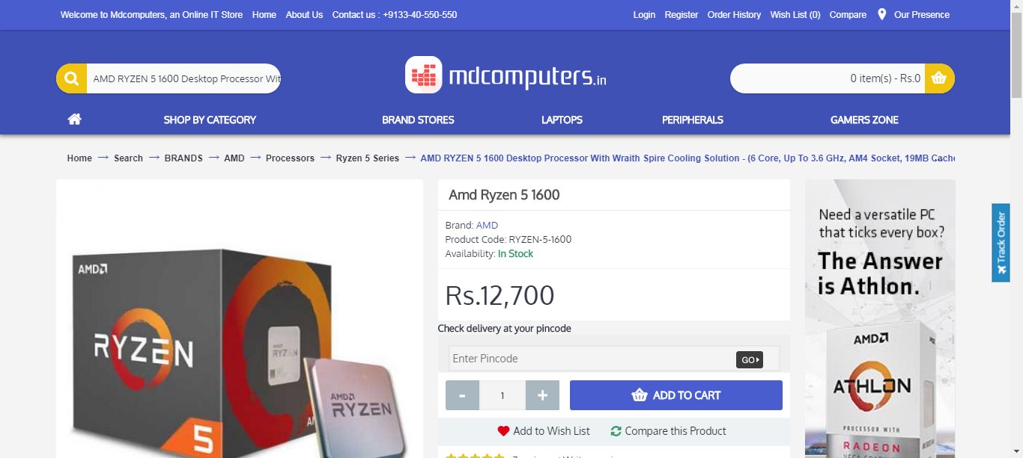  
mdcomputer_processor_29_09_2018_02_05

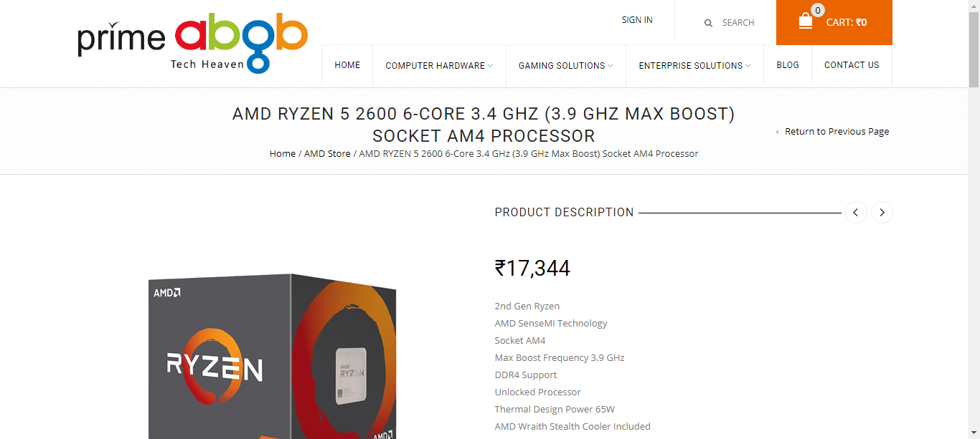  
primebgb_processor_29_09_2018_02_05

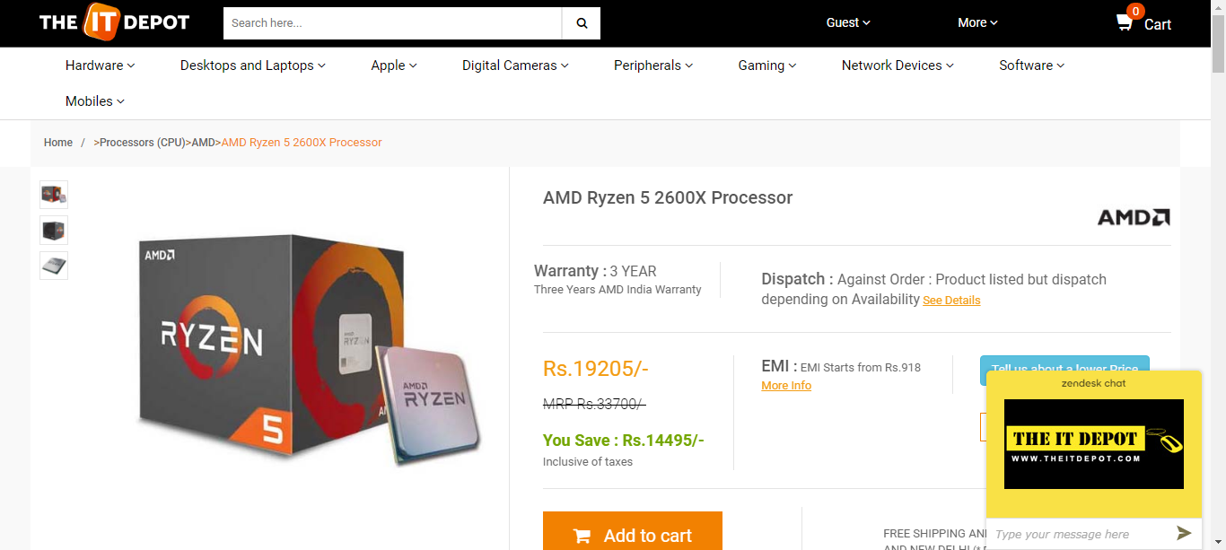  
theitdepot_processor_29_09_2018_03_07

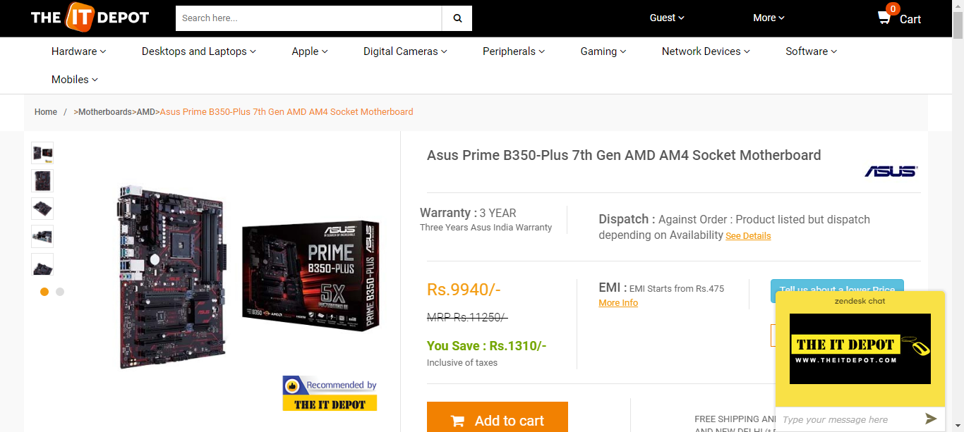  
theitdepot_motheboard_29_09_2018_03_07

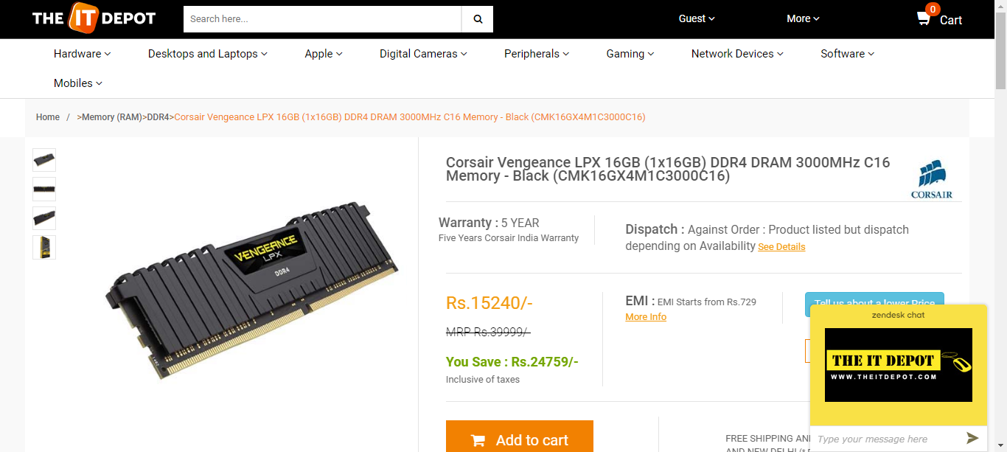  
theitdepot_ram_29_09_2018_03_07

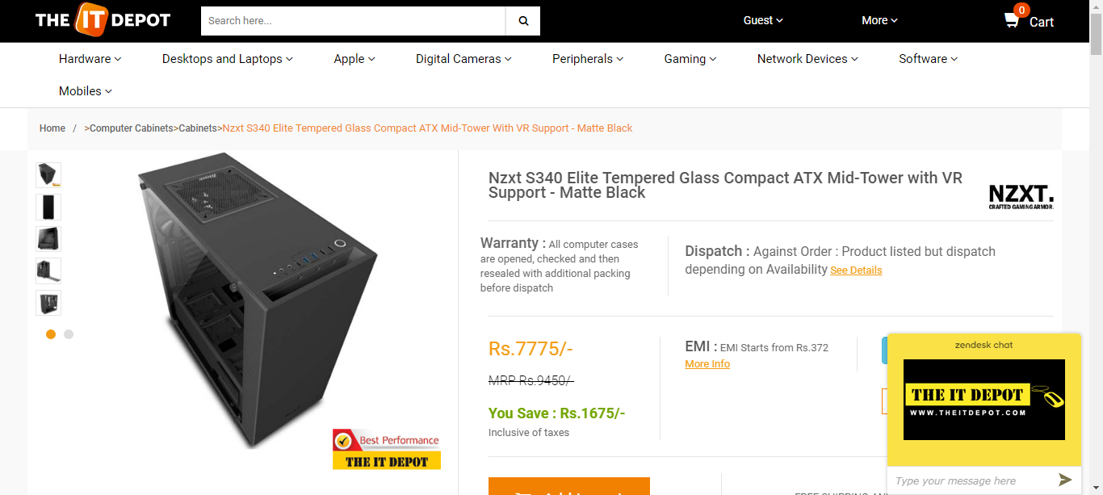  
theitdepot_cabinet_29_09_2018_03_07

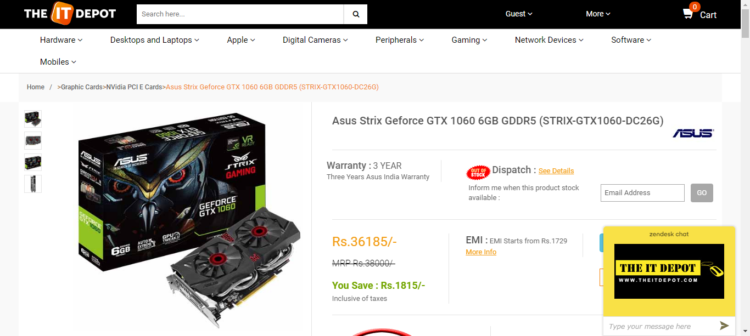  
theitdepot_graphicscard_29_09_2018_03_07

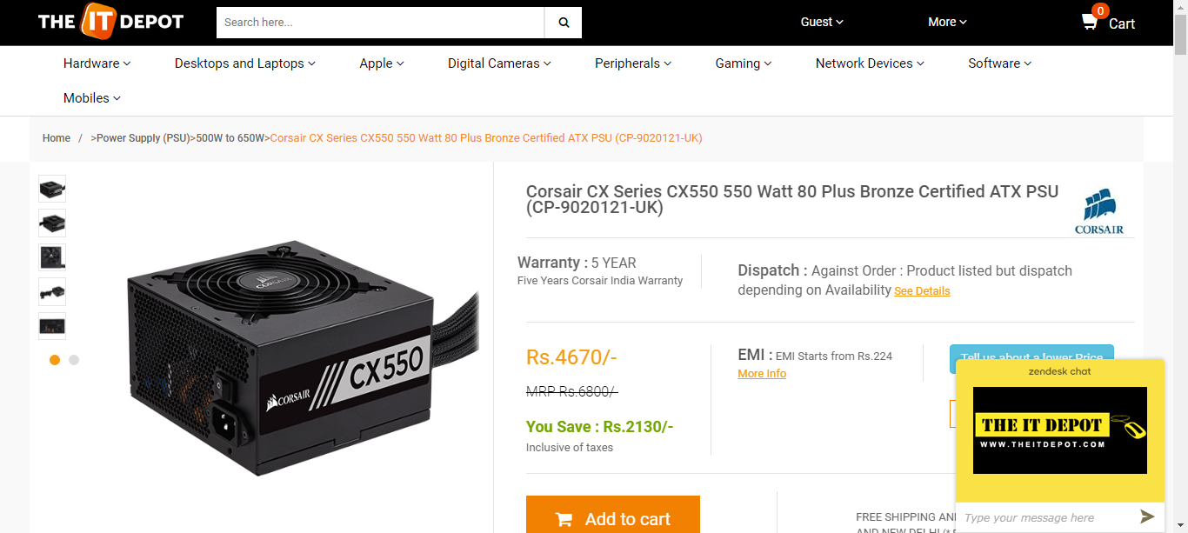  
theitdepot_powerSupply_29_09_2018_03_07

  
mdcomputer_processor_29_09_2018_03_07

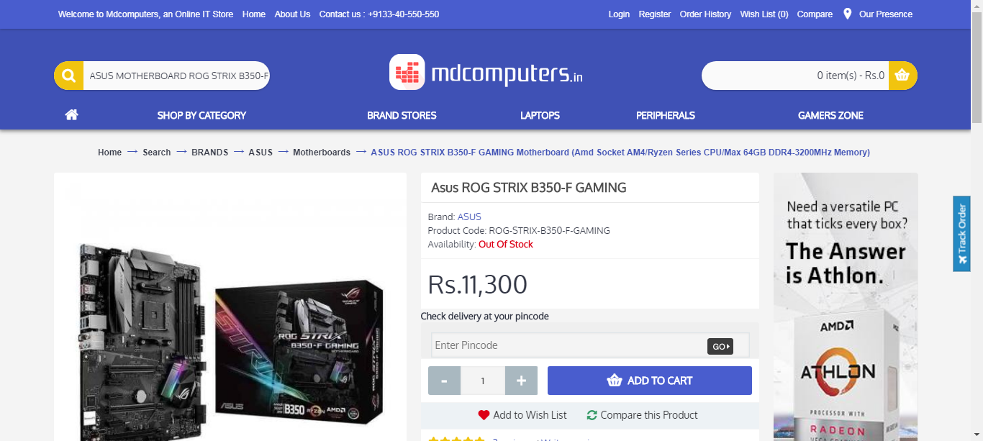  
mdcomputer_motherboard_29_09_2018_03_07

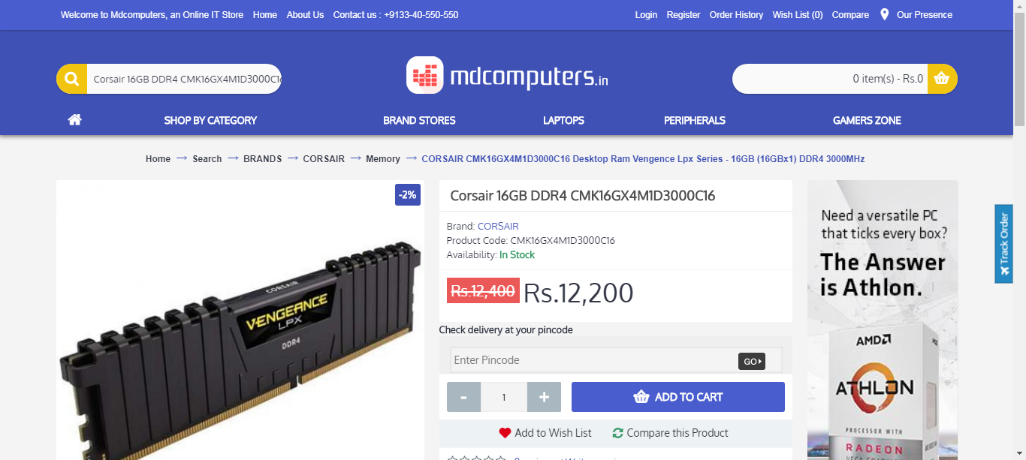  
mdcomputer_ram_29_09_2018_03_07

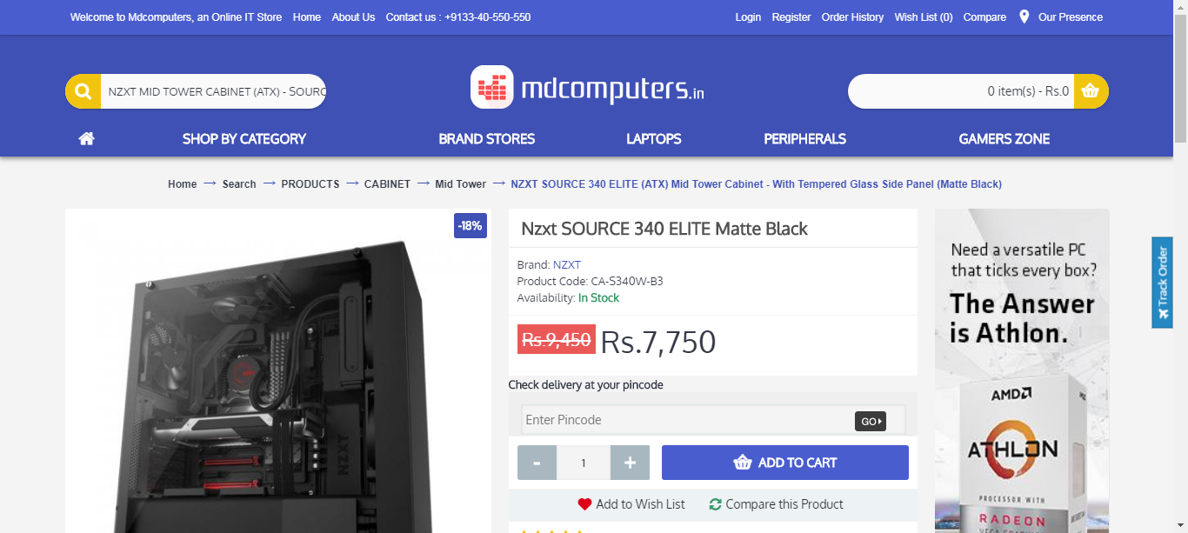  
mdcomputer_case_29_09_2018_03_07

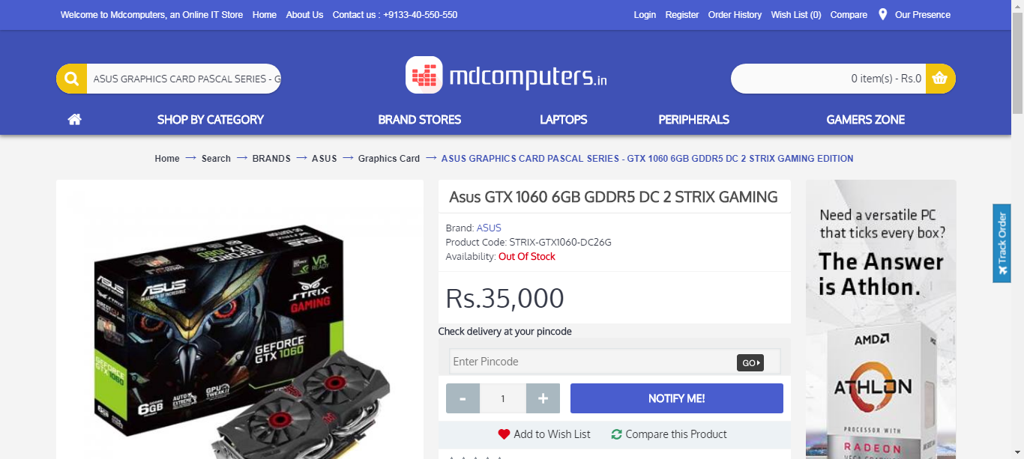  
mdcomputer_graphicsCard_29_09_2018_03_07

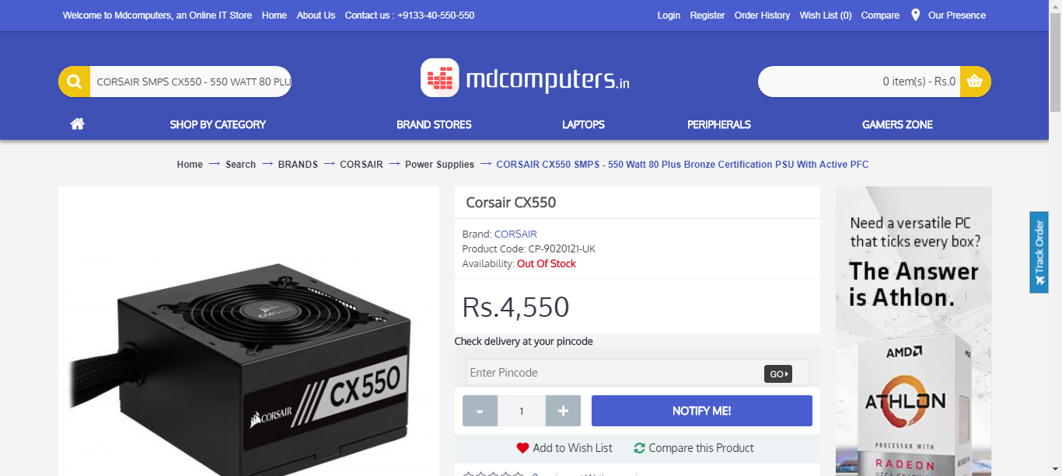  
mdcomputer_psu_29_09_2018_03_07

  
theitdepot_processor_29_09_2018_04_42

  
theitdepot_motheboard_29_09_2018_04_42

  
theitdepot_ram_29_09_2018_04_42

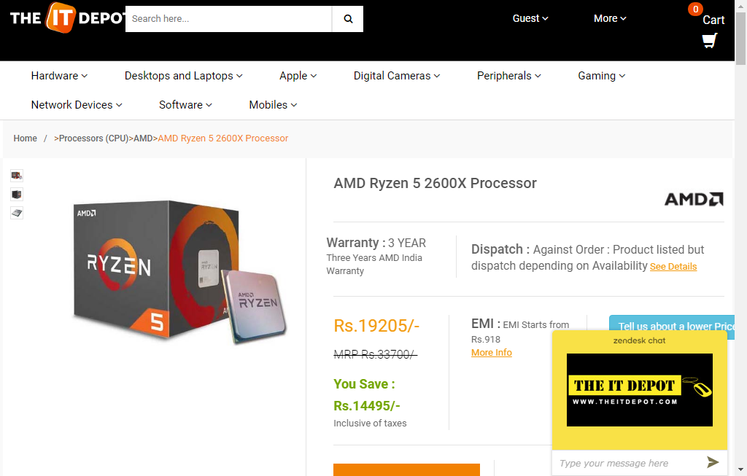  
theitdepot_processor_29_09_2018_04_04

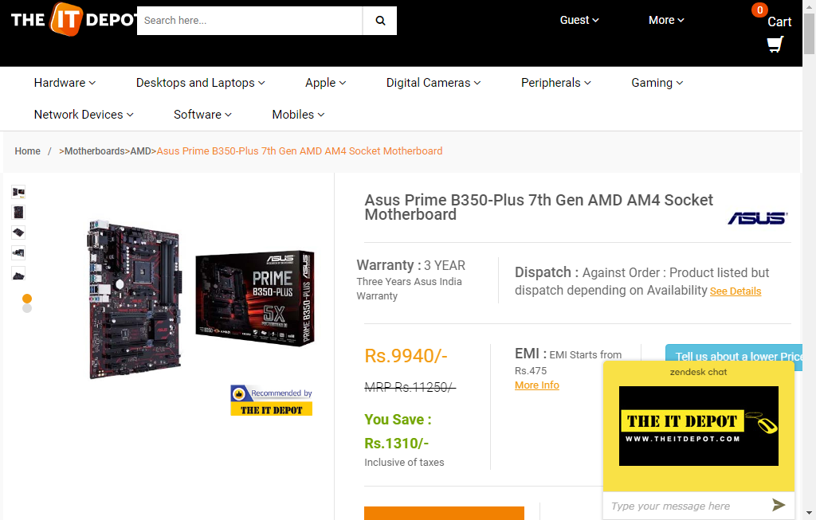  
theitdepot_motheboard_29_09_2018_04_04

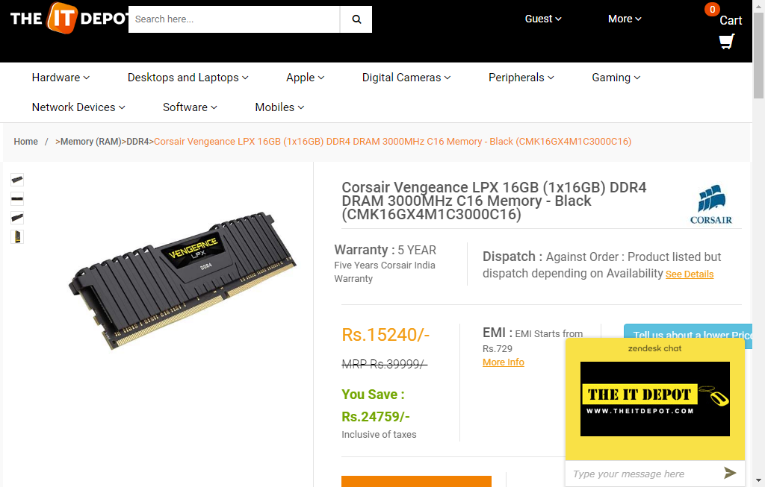  
theitdepot_ram_29_09_2018_04_04

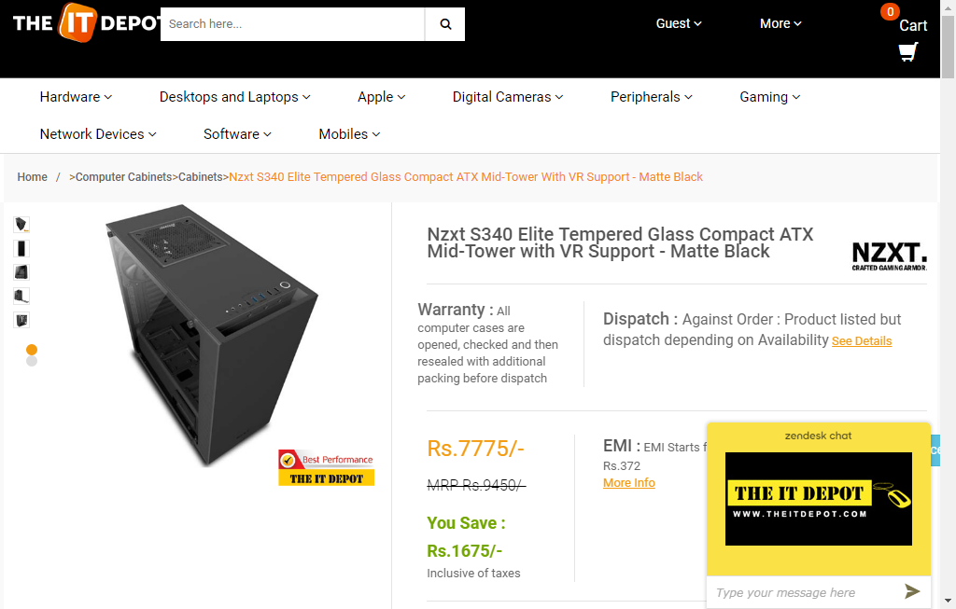  
theitdepot_cabinet_29_09_2018_04_04

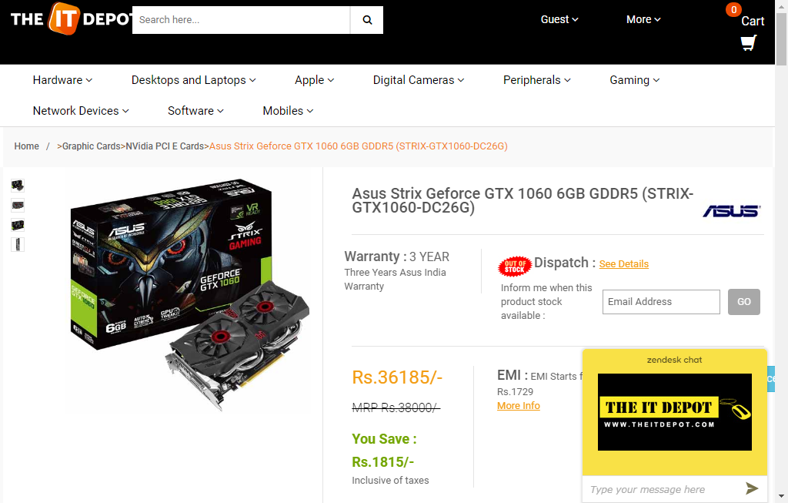  
theitdepot_graphicscard_29_09_2018_04_04

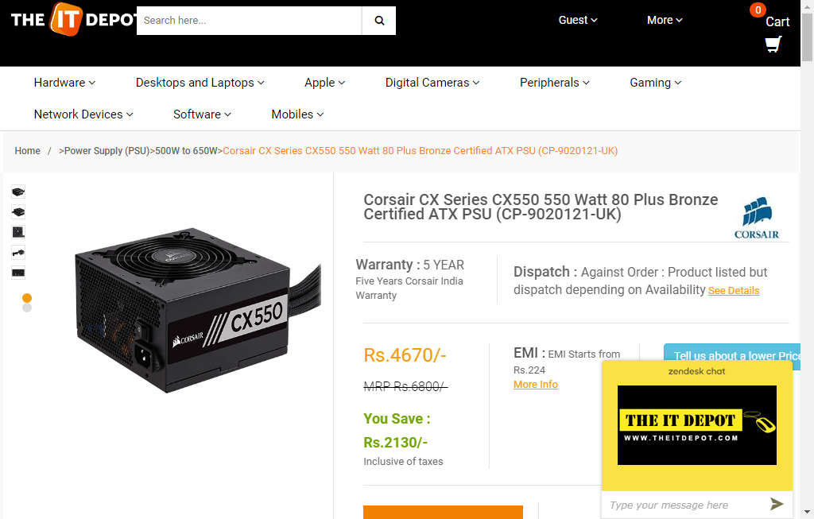  
theitdepot_powerSupply_29_09_2018_04_04

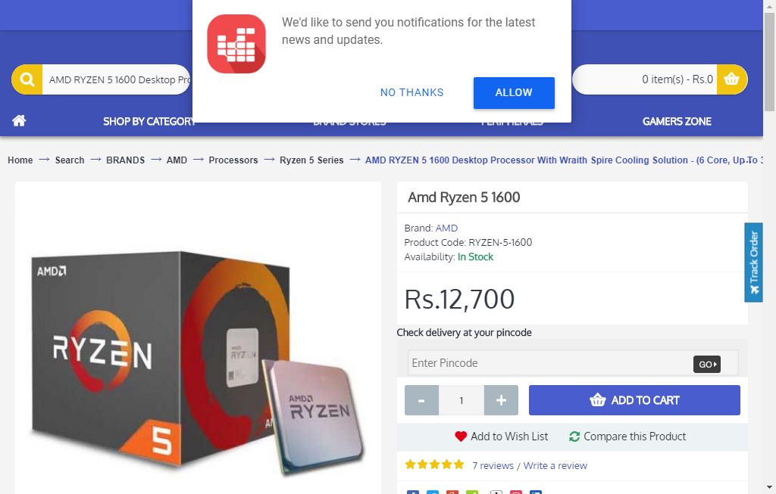  
mdcomputer_processor_29_09_2018_04_04

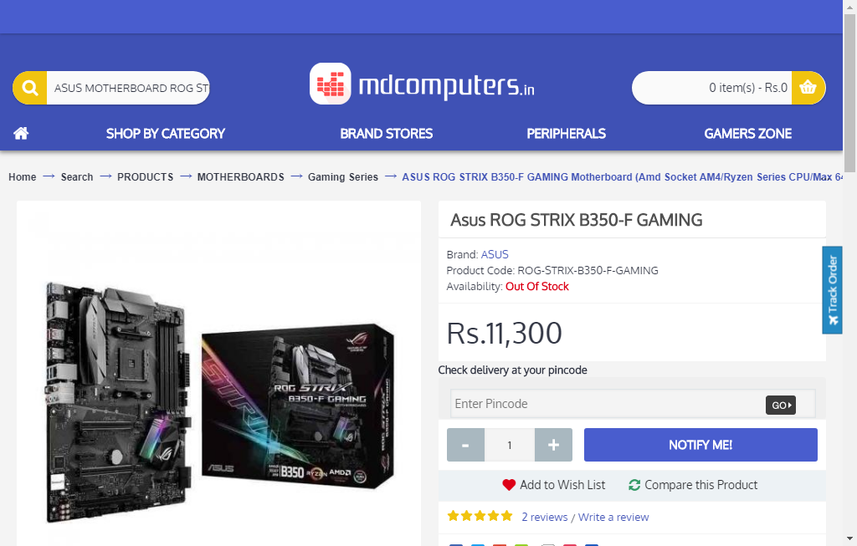  
mdcomputer_motherboard_29_09_2018_04_04

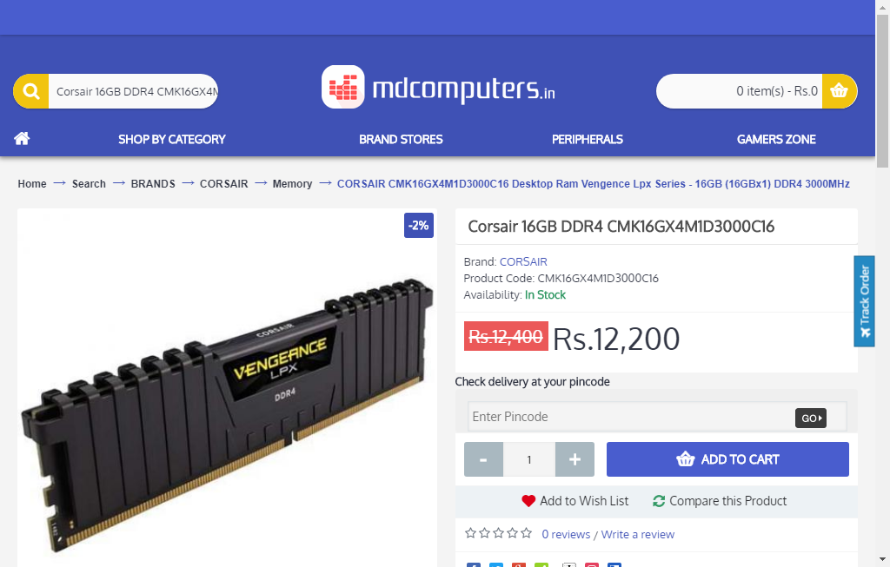  
mdcomputer_ram_29_09_2018_04_04

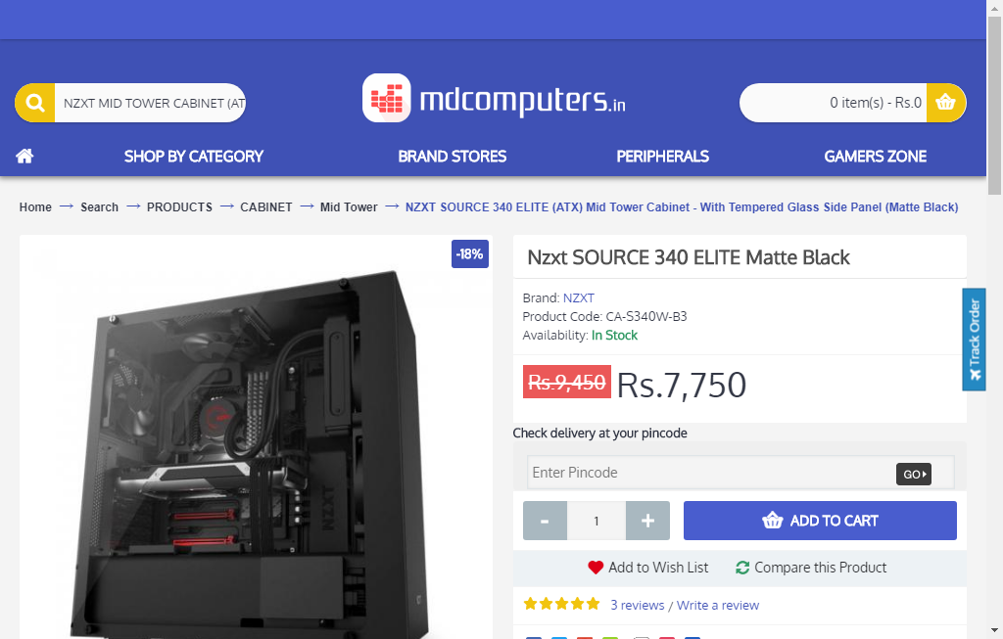  
mdcomputer_case_29_09_2018_04_04

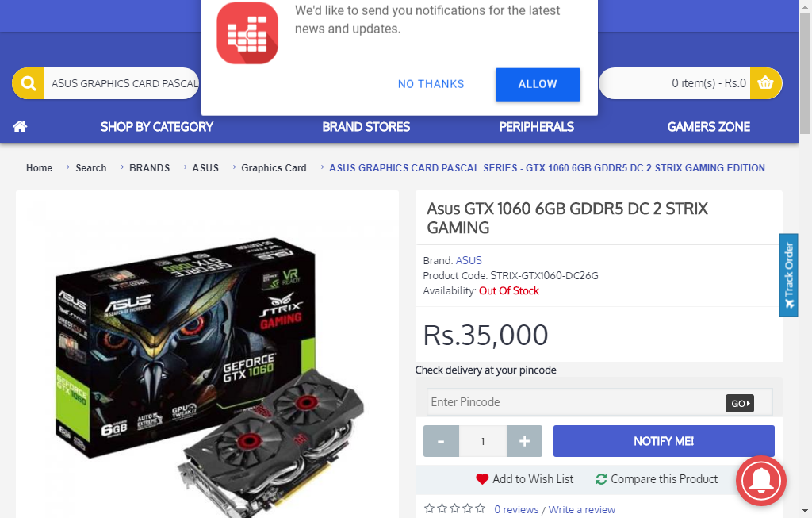  
mdcomputer_graphicsCard_29_09_2018_04_04

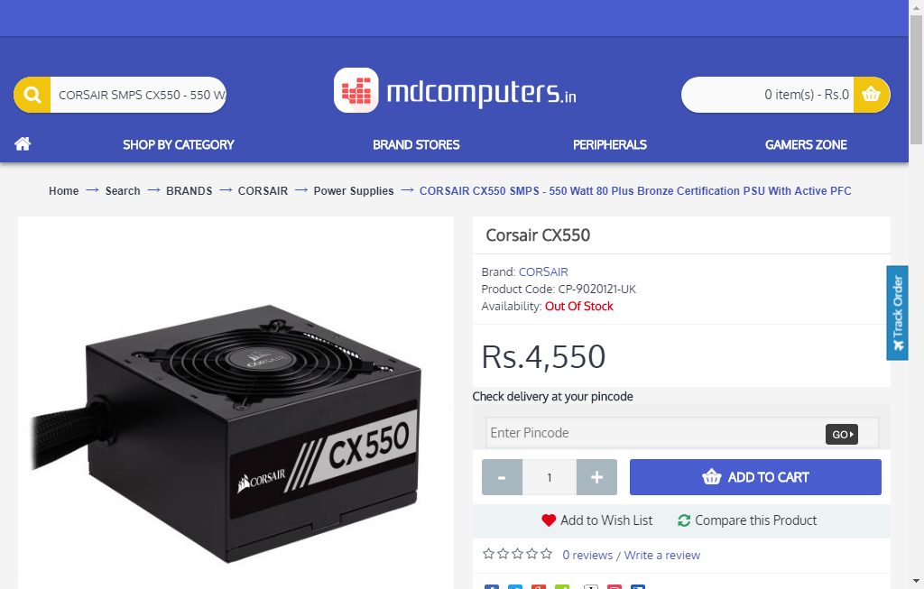  
mdcomputer_psu_29_09_2018_04_04

  
theitdepot_processor_29_09_2018_04_14

  
theitdepot_motheboard_29_09_2018_04_14

  
theitdepot_ram_29_09_2018_04_14

  
theitdepot_cabinet_29_09_2018_04_14

  
theitdepot_graphicscard_29_09_2018_04_14

  
theitdepot_powerSupply_29_09_2018_04_14

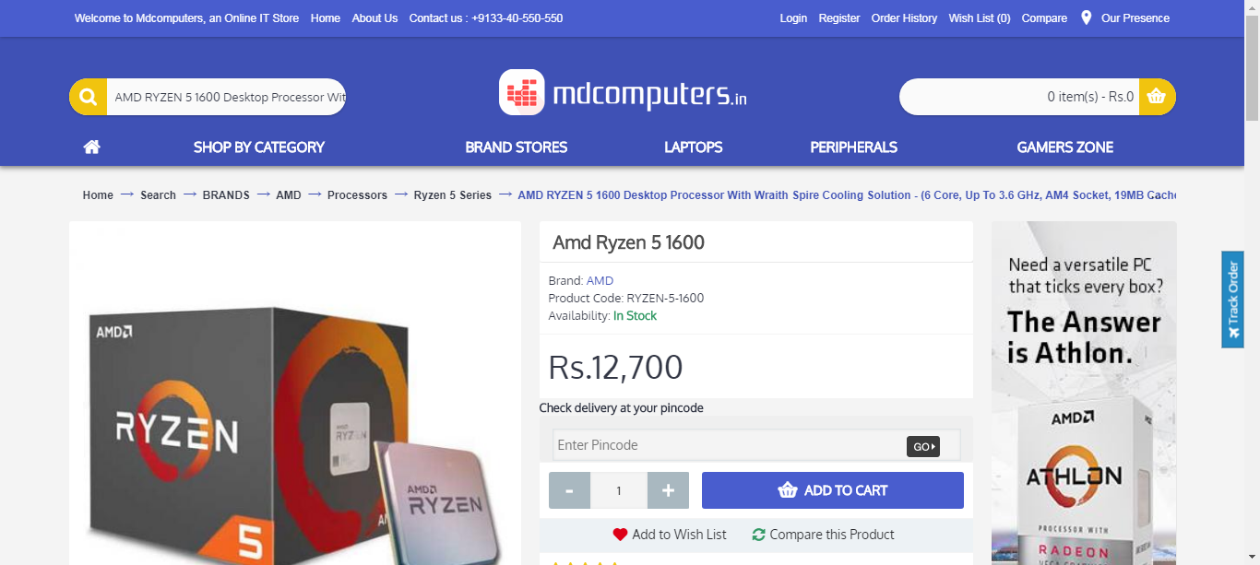  
mdcomputer_processor_29_09_2018_04_14

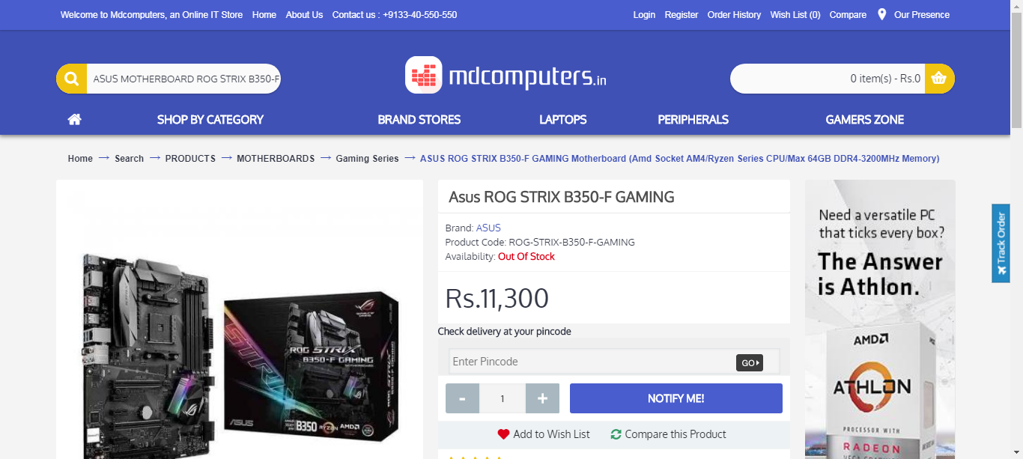  
mdcomputer_motherboard_29_09_2018_04_14

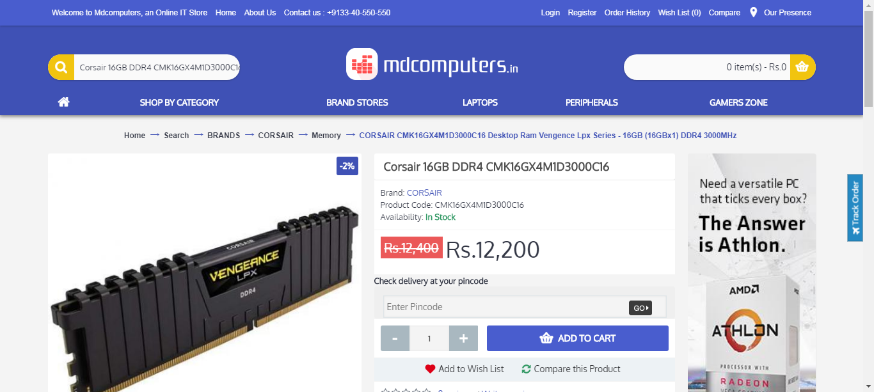  
mdcomputer_ram_29_09_2018_04_14

  
mdcomputer_case_29_09_2018_04_14

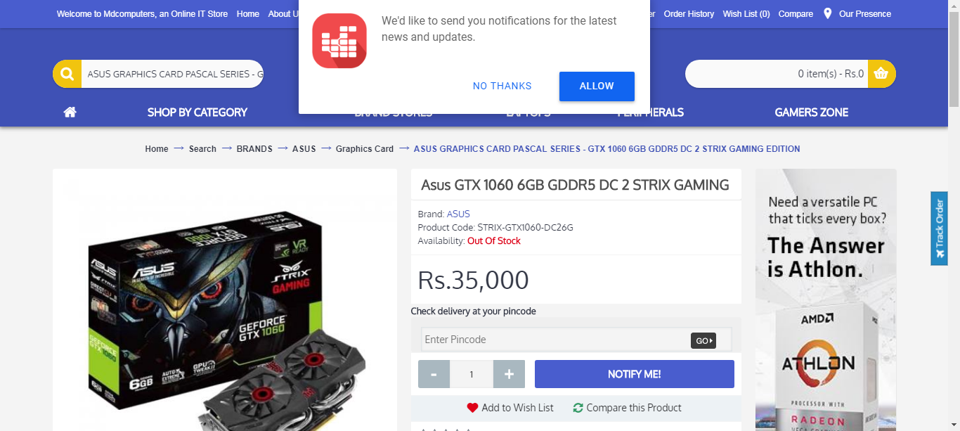  
mdcomputer_graphicsCard_29_09_2018_04_14

  
mdcomputer_psu_29_09_2018_04_14

  
primebgb_processor_29_09_2018_04_14

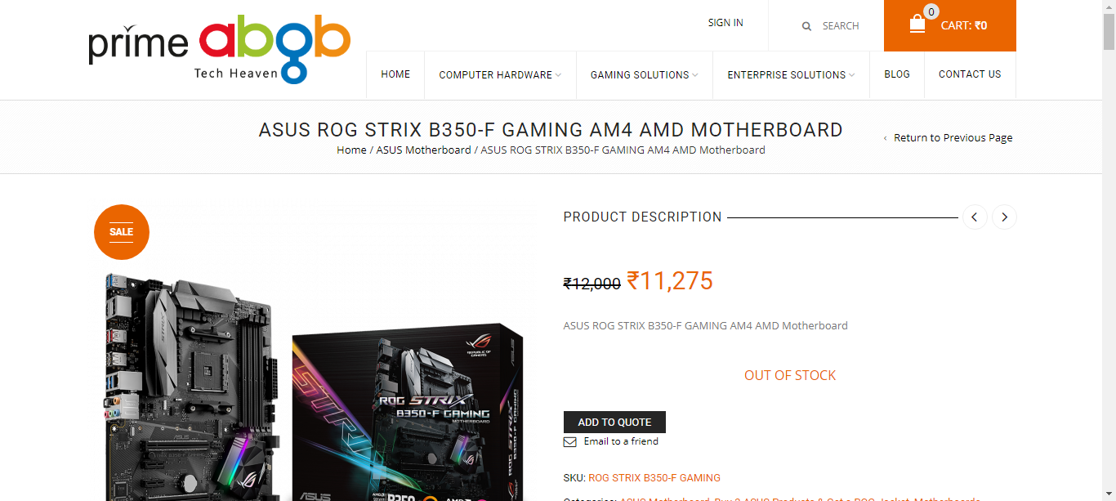  
primebgb_motherboard_29_09_2018_04_14

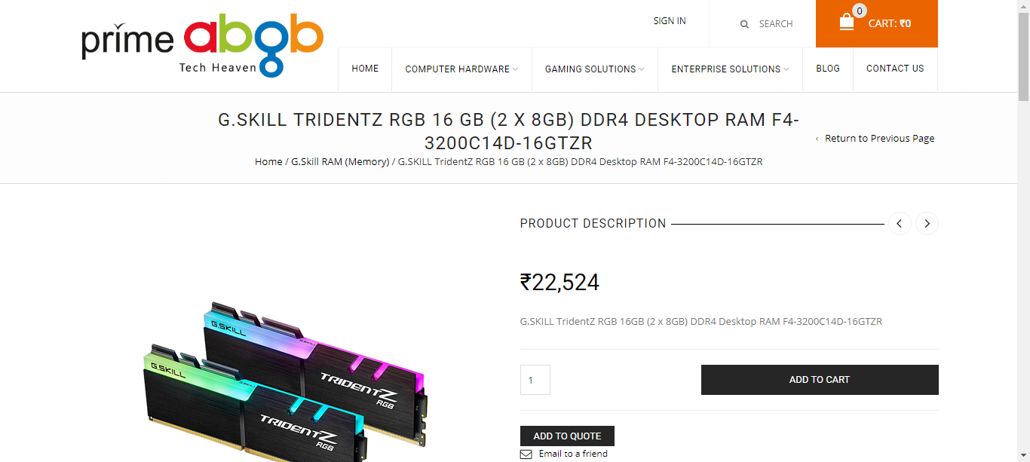  
primebgb_ram_29_09_2018_04_14

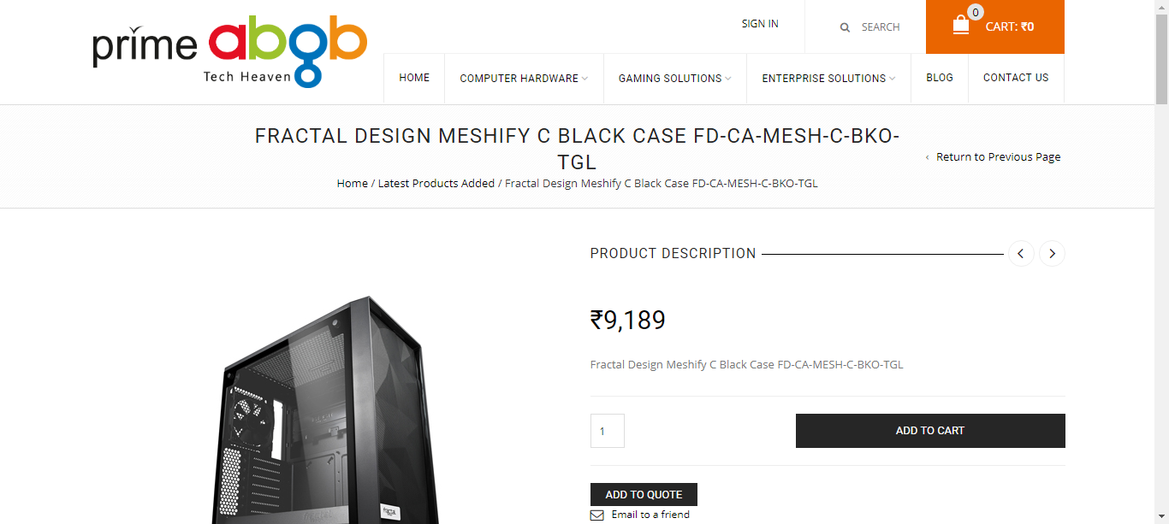  
primebgb_case_29_09_2018_04_14

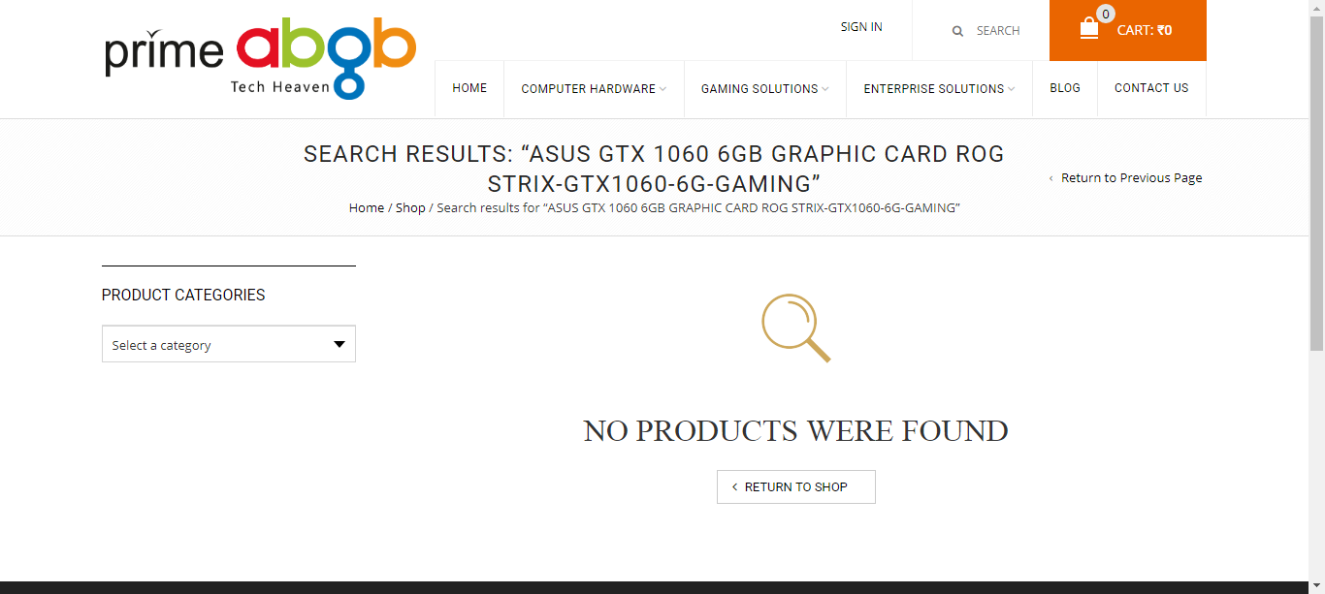  
primebgb_graphicsCard_29_09_2018_04_14

  
theitdepot_processor_29_09_2018_04_20

  
theitdepot_motheboard_29_09_2018_04_20

  
theitdepot_ram_29_09_2018_04_20

  
theitdepot_cabinet_29_09_2018_04_20

  
theitdepot_graphicscard_29_09_2018_04_20

  
theitdepot_powerSupply_29_09_2018_04_20

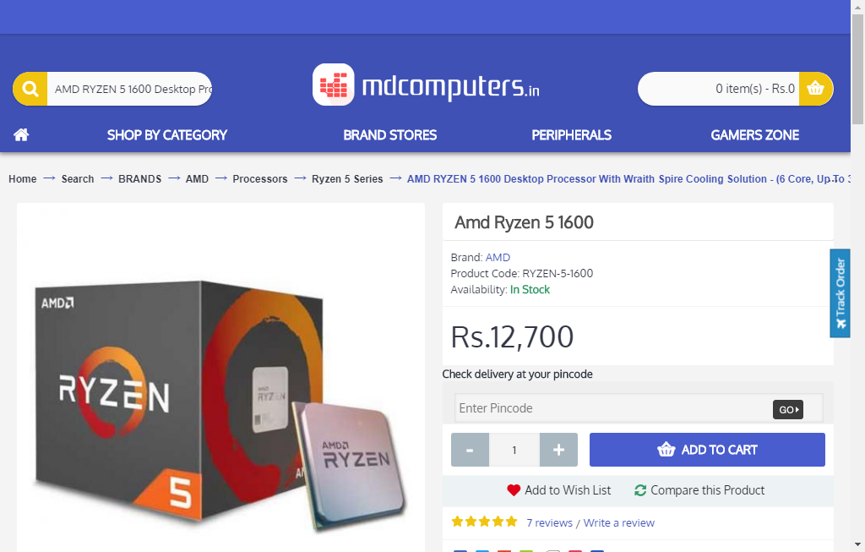  
mdcomputer_processor_29_09_2018_04_20

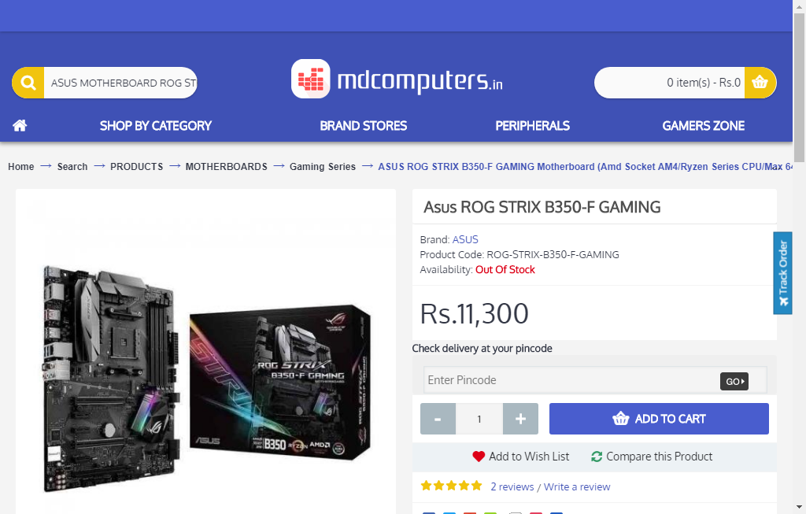  
mdcomputer_motherboard_29_09_2018_04_20

  
mdcomputer_ram_29_09_2018_04_20

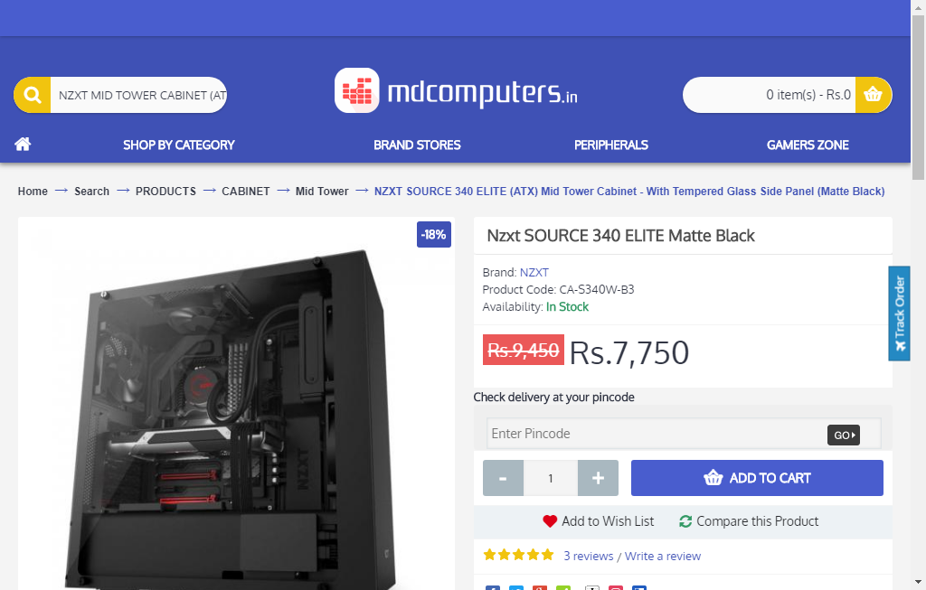  
mdcomputer_case_29_09_2018_04_20

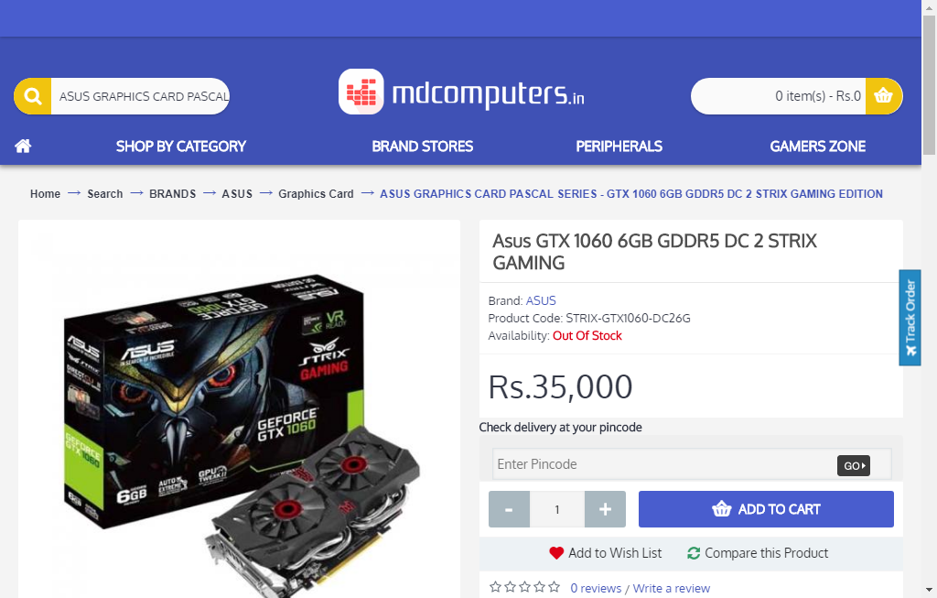  
mdcomputer_graphicsCard_29_09_2018_04_20

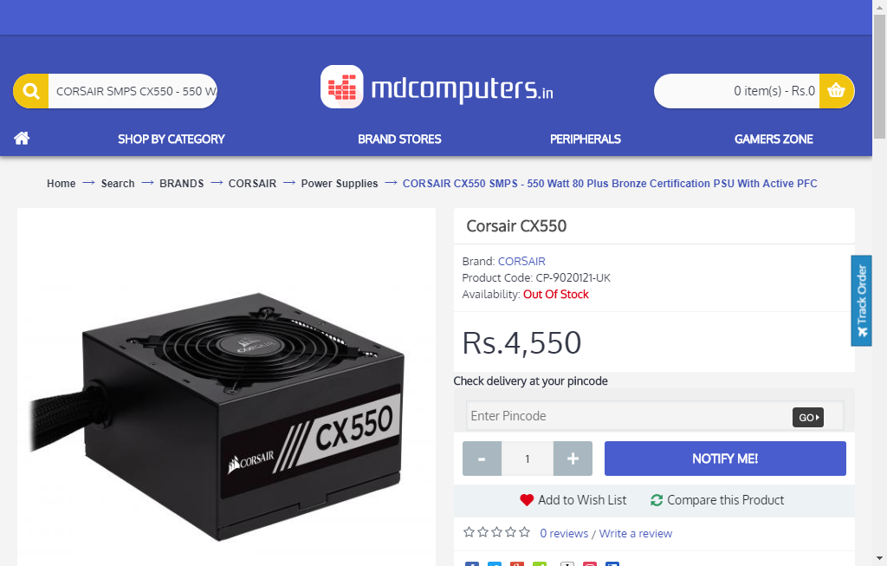  
mdcomputer_psu_29_09_2018_04_20

  
theitdepot_processor_29_09_2018_04_23

  
theitdepot_motheboard_29_09_2018_04_23

  
theitdepot_ram_29_09_2018_04_23

  
theitdepot_cabinet_29_09_2018_04_23

  
theitdepot_graphicscard_29_09_2018_04_23

  
theitdepot_powerSupply_29_09_2018_04_23

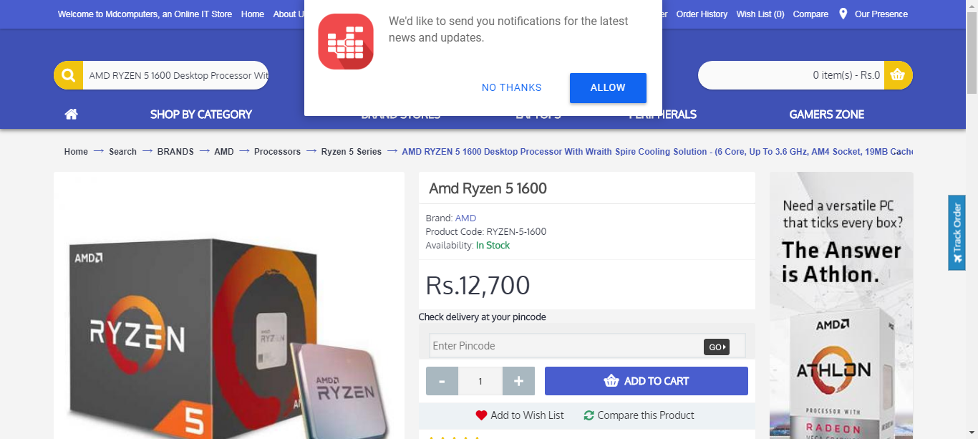  
mdcomputer_processor_29_09_2018_04_23

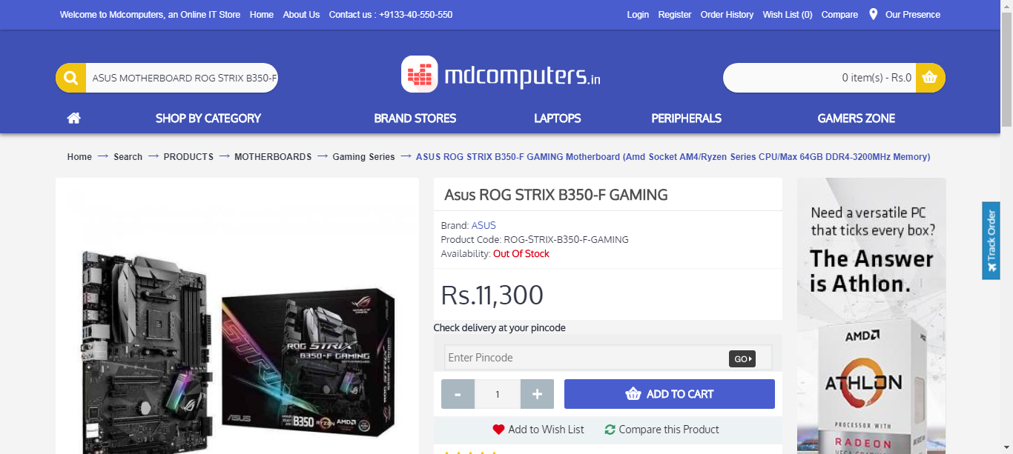  
mdcomputer_motherboard_29_09_2018_04_23

  
mdcomputer_ram_29_09_2018_04_23

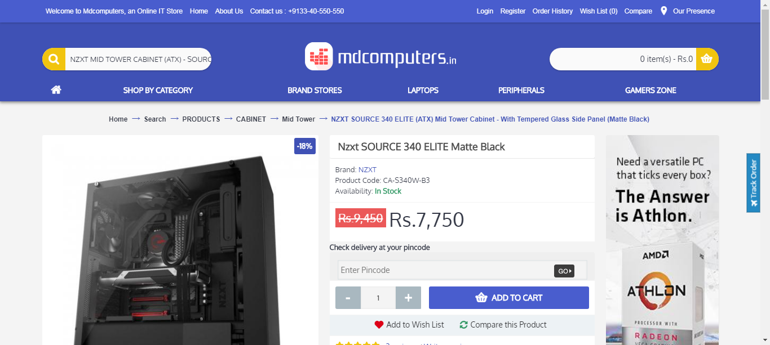  
mdcomputer_case_29_09_2018_04_23

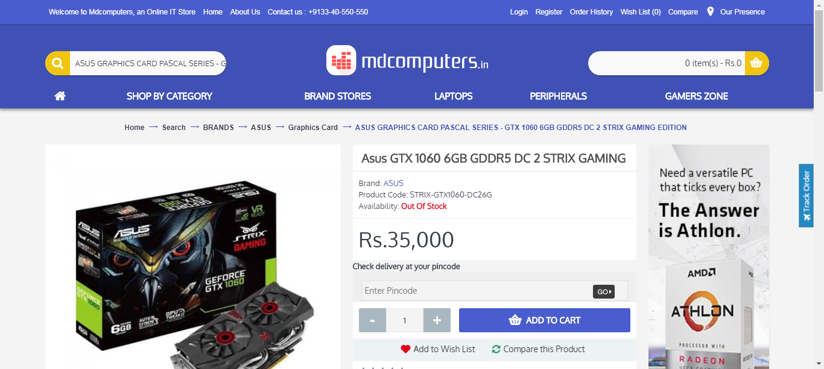  
mdcomputer_graphicsCard_29_09_2018_04_23

  
mdcomputer_psu_29_09_2018_04_23

  
primebgb_processor_29_09_2018_04_23

  
primebgb_motherboard_29_09_2018_04_23

  
primebgb_ram_29_09_2018_04_23

  
primebgb_case_29_09_2018_04_23

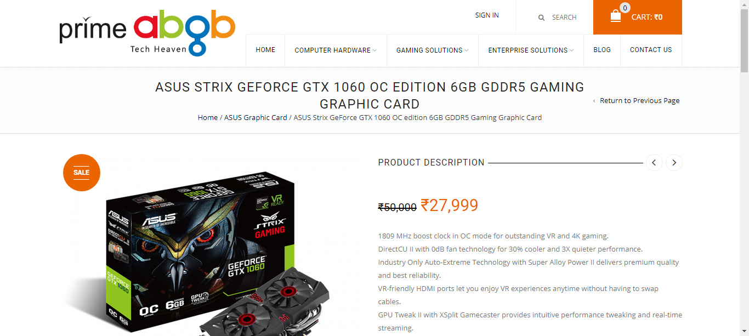  
primebgb_graphicsCard_29_09_2018_04_23

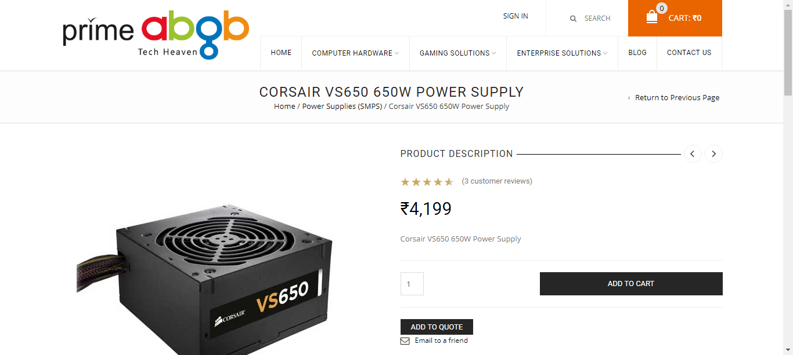  
primebgb_psu_29_09_2018_04_23